

Name: Krishnaraj Prashant Thadesar. Class: F.Y B.Tech Division 9. Batch: I3.

Roll No.: 109054 Expt. No. 7 .

Performed on: 13/09/21 . Submitted on: 18/09/21 . Teacher’s Sign.: .

**Determination Of Coefficient of Restitution Between Two Colliding Bodies**

***Purpose of the experiment:***

To study the Impulse Momentum principle, concept of direct central impact and coefficient of restitution (e). To demonstrate direct central impact and to determine the coefficient of restitution between two bodies by using the concept of collision with a body of infinite mass.

***Instruments:***

Measuring scale, ball, steel plate, Aluminium plate, wooden cabinet of height 1 m attached with measuring scale.

***Theory:***

*Impulse Momentum Principle:*

By Newton’s 2nd Law of motion, we have

$$\begin{aligned}F=m\overline{a}=\frac{d\overline{v}}{dt} \\ Fdt=md\overline{v} \\ \int_{t_{1}}^{t_{2}}{ }Fdt=\int_{u}^{v}{ }md\overline{v} \\ \overline{F}\left(t_{2}-t_{1}\right)=m\left(\overline{v}-\overline{u}\right) \\ \\ now, \end{aligned}$$

$\text{Let }t_{2}-t_{1}=t$*, then we have*

$$(\overline{F}t)=m⋅\overline{v}-m⋅\overline{u}$$

‘F.t’ is called as impulse acting on a particle for time ‘t’.

*Thus, the impulse acting on the particle for time ‘t’ is equal to the change in the linear momentum in that time.*

This is called as Impulse Momentum Principle.



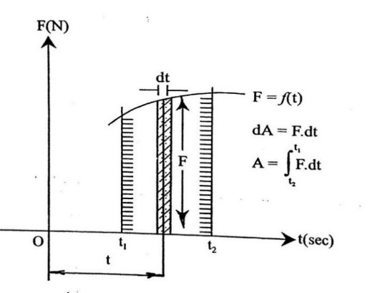

Figure 1. F.t Diagram

Here the force acting on the particle is constant for time ‘t’. If the force acting on the particle is changing and force F = f(t), then the area under the F-t diagram is the impulse acting on the particle for time ‘t’.

*Direct Central Impact:*

Collision of two bodies in which each body exerts tremendous pressure on the other for a very short interval of time is called as impact. When the mass centres of the colliding bodies are lying on the line of impact and their velocities are collinear to the line of impact then it is called are direct central impact.

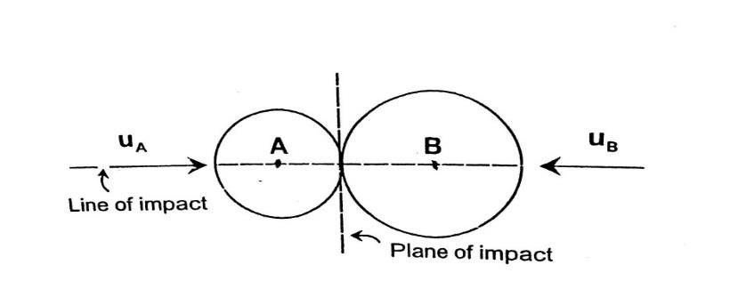

Figure 2. Direct central impact

*Impulse of Deformation:*

When the two colliding bodies touch each other, initially they have a tendency to push the other body. This stage is called as deformation stage. The impulse acting on the body during deformation stage is called as impulse of deformation.

*Impulse of Recovery:*

After the deformation stage, the bodies develop the tendency of separating away from each other. This is called as Recovery stage. Recovery may be 100% or 0% or partial. The impulse acting on the body during recovery stage is called as Impulse of recovery.

Time of impact (Δt) = time of deformation (Δtd) + time of recovery (Δtr)

*Coefficient of restitution:*

The ratio of impulse of recovery to the impulse of deformation is called as coefficient of restitution between the two colliding bodies. It is considered as a constant for given geometries and for a given combination of colliding materials. It also depends on the impact velocity, shape and size of colliding bodies.



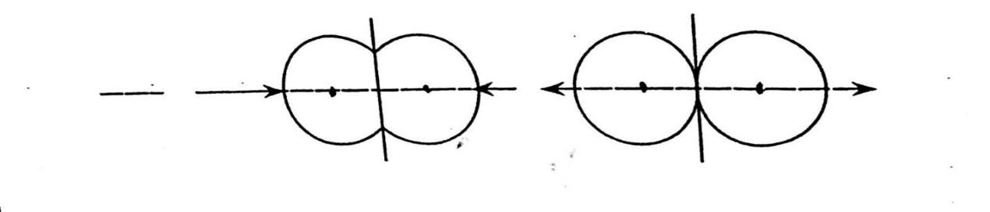

Figure 3. Deformation and recovery stage during impact

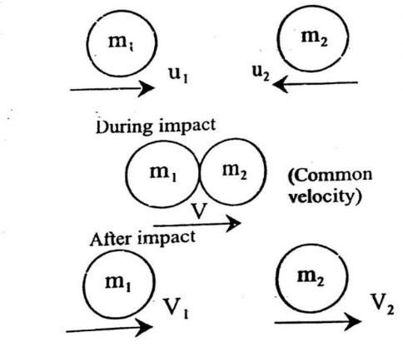Consider two colliding bodies as shown below:

Let

$m_{1}=$*mass of body 1,*

$m_{2}=$*mass of body 2*

$u_{1} =$*Velocity of body 1 before impact,*

$u_{2}=$*Velocity of body 2 before impact*

$v_{1}=$*Velocity of body 1 after impact,*

$v_{2}=$*Velocity of body 2 after impact*

Figure 4. Collision between two bodies

|  |  |  |
| --- | --- | --- |
|  | Impulse of Deformation | Impulse of recovery |
| Body 1 | $${ m}_{1}v-m_{1}u_{1}$$ | $${ m}_{1}v_{1}-m_{1}v$$ |
| Body 2 | $${ m}_{2}v-m_{2}u_{2}$$ | $${ m}_{2}{ V}_{2}-m_{2} V$$ |

$$e=\frac{m_{1}v-m_{1}u}{m_{1}v-m_{1}u_{1}}=\frac{v_{1}-u}{v-u_{1}}=\frac{m_{2}v_{2}-m_{2}v}{m_{2}v-m_{2}}=\frac{v_{2}-u}{v-v_{2}}$$

$$e=\frac{v_{1}-v_{2}}{v-v_{1}}=\frac{v_{2}-v}{v-u_{2}}=\frac{v_{1}-v-v_{2}+v}{v-u_{1}-v+u_{2}}$$

$$e=\frac{v_{1}-v_{2}}{u_{2}-u_{1}}=\left[\frac{v_{1}-v_{2}}{u_{1}-u_{2}}\right]=\frac{v_{1/2}}{u_{1/2}}$$

$$e=\left[\frac{v_{1}-v_{2}}{u_{2}-u_{1}}\right]$$

$$\begin{matrix}e=-\left(\frac{\text{ relative velocity of }1\text{ wrt }2\text{ after impact }}{\text{ relative velocity of }2\text{ wrt }1\text{ before impact }}\right) \\ \end{matrix}$$

$$e=-\left(\frac{\text{ velocity of separation }}{\text{ velocity of approach }}\right)$$

i.e., mass will not have any effect on the coefficient of restitution.



*Collision with a body of infinite mass:*

Consider the impact between ball and floor.

If a ball (body 1 of finite mass $m$) be released from height $h1$.It strikes the floor (body 2 of infinite mass) and rebounds to height $h_{2}$ after impact as shown in fig. 5.

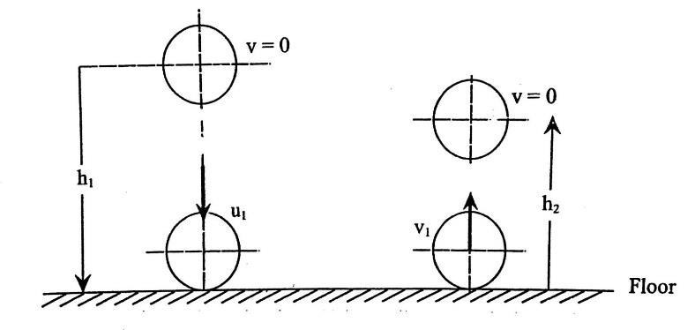

Figure 5: Collision with a body of infinite mass

$$\begin{matrix} & u_{1}=\text{ striking velocity } & v_{1}=\text{ Rebounding velocity } \\ & u_{1}=\sqrt{2g h},(↓) & u_{1}=\sqrt{2g{ h}_{2}}(↑)\end{matrix}$$

For body $2,u_{2}=v_{2}=0$

$$∴e=\frac{v_{1}-v_{2}}{u_{1}-u_{2}}=\frac{v_{1}}{-u_{1}}=\frac{\sqrt{2{gh}_{2}}}{\sqrt{2{gh}_{2}}}e=\sqrt{\frac{h_{2}}{{ h}_{1}}}$$

Based on coefficient of restitution the phenomenon of impact is classified into three:

1. *Elastic impact*
2. *Semi-elastic impact*
3. *Plastic impact*

The characteristics of these three types of impacts are as under:

*Elastic Impact:*

1. The two bodies separate after the impact.
2. Coefficient of restitution, e = 1
3. Linear momentum is conserved

$\left(m_{1}u_{1}+m_{2}u_{2}=m_{1}v_{1}+m_{2}v_{2}\right)$.

1. Kinetic energy is conserved.

*(K.E. of the system before impact) = (K.E. of the system after impact).*

$$\left(\frac{1}{2}m_{1}u_{1}^{2}+\frac{1}{2}m_{2}u_{2}^{2}\right)=\left(\frac{1}{2}m_{1}v_{1}^{2}+\frac{1}{2}m_{2}v_{2}^{2}\right)$$

1. Recovery is $100\%$ and the two bodies regain their original shape and size



*Semi-elastic Impact:*

1. The two bodies separate after the impact.
2. Coefficient of restitution varies between zero and one, $0<e<1$.
3. Linear momentum is conserved

$\left(m_{1}u_{1}+m_{2}u_{2}=m_{1}u_{1}+m_{2}v_{2}\right)$*.*

1. Kinetic Energy of system is not conserved.

*(K. E. of the system before impact) > (K.E. of the system after impact).*

$$\left(\frac{1}{2}m_{1}u_{1}^{2}+\frac{1}{2}m_{2}u_{2}^{2}\right)>\left(\frac{1}{2}m_{1}v_{1}^{2}+\frac{1}{2}m_{2}v_{2}^{2}\right)$$

*Energy lost in impact $=\left(T_{1}-T_{2}\right)$*

$\%$*loss in energy $=\left(\frac{T_{1}-T_{2}}{{ T}_{1}}\right)×100$*

1. The recovery is partial and there is same permanent damage of the bodies.

*Plastic Impact:*

1. The two bodies do not separate after the impact but they move with a common velocity ' $v^{'}$.
2. Coefficient of restitution $e=0$
3. Linear momentum is conserved
$$\left(m_{1}u_{1}+m_{2}u_{2}\right)=\left(m_{1}+m_{2}\right)v$$

4. There is a great loss of Kinetic Energy and it is not conserved.

*(K.E. of the system before impact) > (K.E. of the system after impact)*

$\left(\frac{1}{2}m_{1}u_{1}^{2}+\frac{1}{2}m_{2}u_{2}^{2}\right)>\left(\frac{1}{2}m_{1}v_{1}^{2}+\frac{1}{2}m_{2}v_{2}^{2}\right)$

*Energy lost in impact $=\left(T_{1}-T_{2}\right)$*

$\%$*loss in energy $=\left(\frac{T_{1}-T_{2}}{{ T}_{1}}\right)×100$*

1. The recovery is partial and there is some permanent damage on the colliding bodies.



***Procedure: -***

1. Place the wooden cabinet of height 1 m on a horizontal plane surface.
2. Release a rubber ball from the central hole at the top of the cabinet i.e., from a height ‘h1’. (h1= 1 m for the lab setup). The ball will fall vertically through 1 m height and strike the base of the cabinet. It will then rebound
3. Measure the height of rebound ‘h2’ from two directions which are perpendicular to each other, with the help of the meter scale attached inside the cabinet on the two perpendicular sides of the cabinet. Take the average of these two readings. This is the final height of rebound ‘h2’.
4. Take three such readings.
5. Calculate the coefficient of restitution (between rubber and wood) using the formula.
$$e=\sqrt{\frac{h_{2}}{h_{1}}}$$

6. Place steel plate at the base of the cabinet. Repeat the above procedure and calculate the coefficient of restitution between rubber and steel
7. Now place the Aluminum plate at the base of the cabinet. Repeat the above procedure and calculate the coefficient of restitution between rubber and aluminum.



***Observations:***

|  |  |  |  |  |  |  |  |
| --- | --- | --- | --- | --- | --- | --- | --- |
| Sr.  No. | Materials | Height h1 cm | Height h2 in cm (after impact) | | | | Coefficient of Restitution $$e=\sqrt{\frac{h_{2}}{h_{1}}}$$ |
| 1 | 2 | 3 | h2 average (cm) |
| 1. | Rubber and wood | 82 | 42 | 45 | 45 | 44 | 0.732 |
| 2. | Rubber and  Steel | 82 | 43 | 41 | 43 | 42.33 | 0.718 |
| 3. | Rubber and  Aluminum | 82 | 43 | 44 | 44 | 43.66 | 0.729 |

***Results: -***

|  |  |  |  |
| --- | --- | --- | --- |
| Coefficient of restitution | Between  Rubber and wood | Between  Rubber and steel | Between Rubber and aluminum |
| e | 0.732 | 0.718 | 0.729 |



***Calculations:***

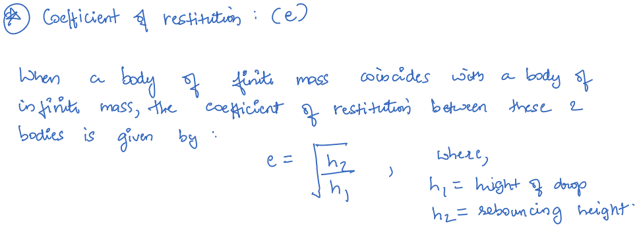

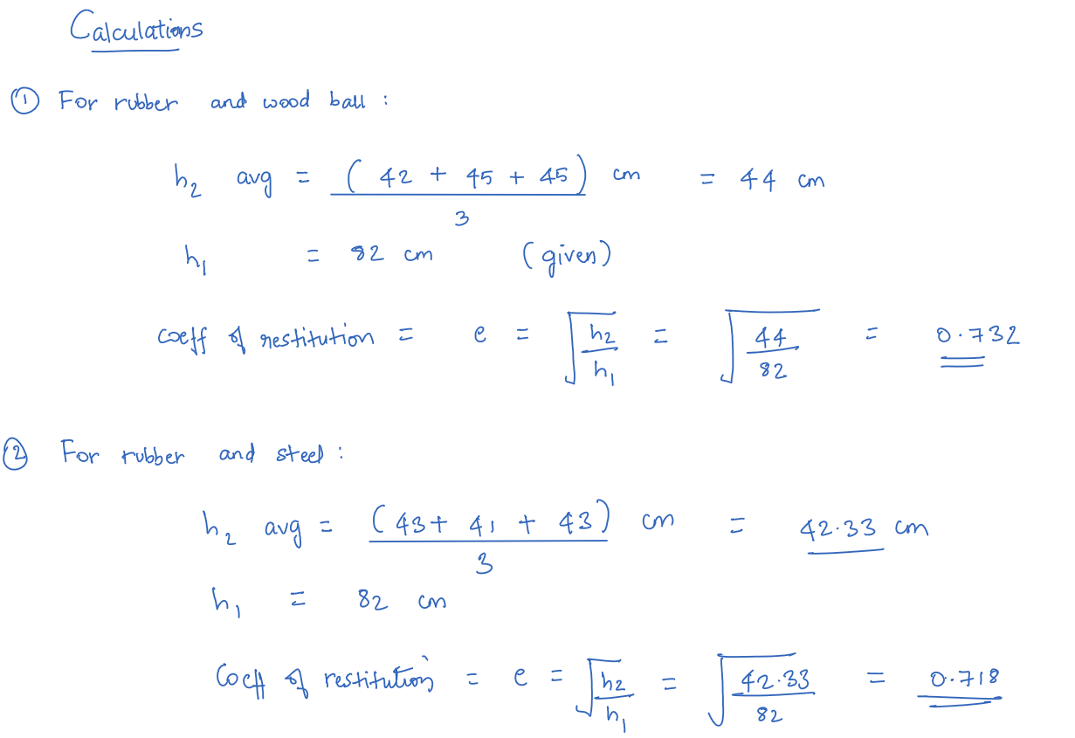

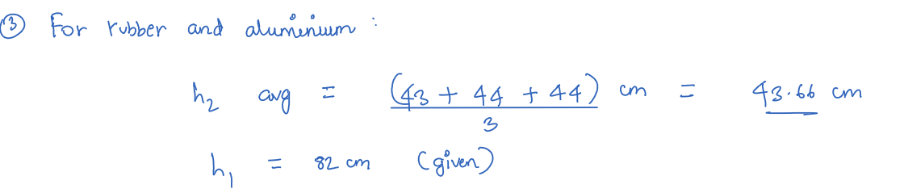





***Conclusion:***

*The Impulse moment principle was studied, and the coefficient of restitution between two bodies by using the concept of collision with a body of infinite mass was calculated to be* ***0.732, 0.718, and 0.729*** *respectively for Rubber and wood, Rubber and steel, Rubber and Aluminum respectively.*

***Questions: -***

1. What is direct central impact?
2. When two bodies apply tremendous forces on one another in the form of collision for an exceptionally short time span, it is referred to as impact.

Direct impact is seen when the center of gravity/mass of the bodies colliding lies on the line of impact as well as their velocities, hence the impact is experienced along the normal at their point of contact during collision.

1. What is conservation of linear momentum?
2. Conservation of linear momentum states that the momentum of a system remains constant if the net external force acting on the system of bodies remains constant, that is if the system remains isolated, the motion never changes.
3. What is the expression for coefficient of restitution for collision of two bodies of finite masses?
4. Expression is given by:

$$e=\frac{v_{1}-v_{2}}{u_{1}-u_{2}}$$

Where e is the coefficient of restitution for two bodies & u1 and u2 are velocities of bodies 1 and 2 before impact while $v1$ and $v2$ are velocities of bodies 1 and 2 after impact.

1. What is the expression for coefficient of restitution for the collision of a body of finite mass with a body of infinite mass?
2. Expression:

$$e=\frac{v_{1}}{-u_{1}}=\frac{\sqrt{2gh_{2}}}{\sqrt{2gh_{1}}}=\sqrt{\frac{h_{2}}{h_{1}}}$$

This is for coefficient of restitution for the collision of a body of finite mass with a body of infinite mass where he is the coefficient of restitution. Here: $h1$ is the height from which the body of finite mass is released and $h2$ is the height to which it rebounds after impact to the infinite massed surface/object.

1. What is the difference between elastic, semi elastic and plastic impact?
2. Impacts in colliding objects can be of 3 types:

Elastic, Semi Elastic, Plastic

Elastic collisions are usually referred to as ideal collisions too. That's because in elastic impacts, there is no loss of kinetic energy (due to losses caused in the form of heat/sound) that occurs during



the collision of bodies. Thus, the deformations caused if any, can be recovered perfectly.

This also implies that the relative velocity of separation after collision is equal to the relative velocity of approach before collision establishing e=1.

On the other hand, in *plastic collisions or impacts*, some portion of the kinetic energy is changed to other forms of energy like heat and sound during the collision. The deformations thus caused are more permanent in nature. Due to this tendency, post collision both objects have same velocity and their relative velocity becomes zero causing e=0.

The intermediate between both an elastic collision and a plastic collision encompasses *semi-elastic collisions*. Here, a little below the perfect 100 percent of the kinetic energy is conserved but it is not as much to force the objects into sticking together post impact. This is the most common one observed in our day to day lives where the relative velocity of separation after collision is less than the relative velocity of approach before collision making e to fall in a range:

0<e<1.

[e mentioned above is the ratio of velocity of separation to the velocity of approach is called the coefficient of restitution]